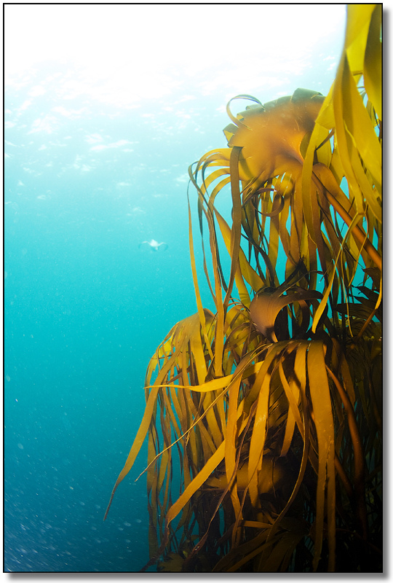
The use of innovative technologies for the production of biologically active substances from hydrobionts and waste from their processing by the fishing industry.

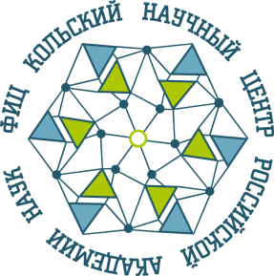
FEDERAL AGENCY FOR SCINTIFIC ORGANIZATION
Research Center for Human Adaptation in the Arctic
Branch of the Federal Research Center
«Kola Science Center of Russian Academy of Science»

International scientific and practical conference
HIDROBIONTS AND BIOTECHNOLOGY IN THE ARCTIC MEDICINEМеждународная научно-практическая конференция
«ГИДРОБИОНТЫ И БИОТЕХНОЛОГИИ В АРКТИЧЕСКОЙ МЕДИЦИНЕ»

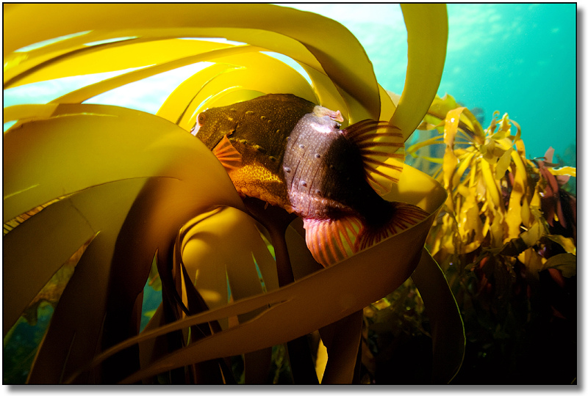
Creation of domestic natural medicines and food additives based on collagen compounds and other biologically active substances derived from fish skins and other fish industry wastes as additional (complex) therapy, treatment and prevention of diseases in the Arctic region

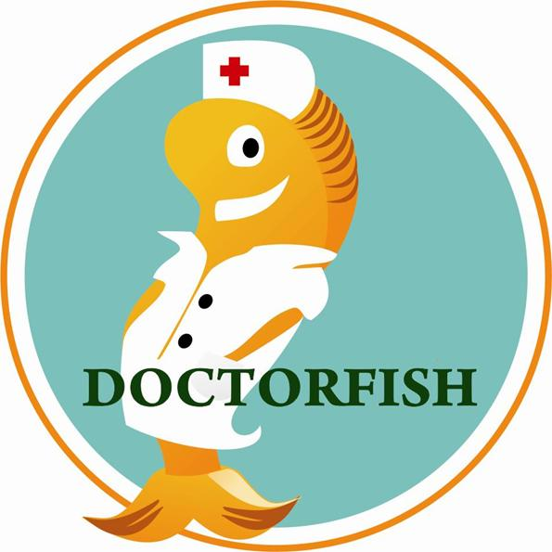
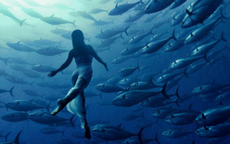

20-24 June 2018 Apatity, Murmansk region,Russia

Dear colleague!
We invite you to take part in The international scientific and practical conference "Hydrobionts and biotechnologies in Arctic medicine" of The research center of Medical and biological problems of human adaptation in the Arctic of the Kola scientific center of RAS, which will be held on June 20-24, 2018, Apatity, Murmansk region, Russia
Research area – the potential and possibilities of using hydrobiological resources as a source of production of biologically active substances, biomedical materials and technologies based on the unique properties of hydrobionts compared to other materials, in the framework of the complex of scientific and applied tasks defined By the strategy of the Arctic zone of the Russian Federation for the period up to 2020.
The purpose of the conference is to exchange knowledge, experience and results of fundamental, exploratory and applied scientific research between academic experts, representatives of industry and government aimed at obtaining new methods and organization of technology transfer in the field of human adaptation to natural and anthropogenic factors of the Arctic environment.
In addition, it is an opportunity to discuss the practical problems faced by the representatives of science, industry and government, and the best way to find solutions.
Main directions of the conference:
1. "The use of innovative technologies for the production of biologically active substances from hydrobionts and their recycling by fish industry enterprises for the purpose of production of new products and waste disposal".
2. "Creation of natural medicines and food additives based on collagen compounds and other biologically active substances derived from fish skins and other fish industry wastes as additional (complex) therapy, treatment and prevention of diseases of the body of the Arctic region residents."
Оrganizing Committee

Chairman:
Sergey V. Krivovichev – Full Professor, member-corr. Russian Academy of Sciences, Chairman of the Federal Research Center «Kola Science Center of Russian Academy of Science»

Deputy chairman:
Vladimir V. Megorsky – Candidate of Medical PhD, Director of Research Center for Human Adaptation in the Arctic
Branch of the Federal Research Center «Kola Science Center of Russian Academy of Science»

Co-chairmen:
Vladimir A.Masloboev-Doctor of Engineering Sciences, Vice-Chairman of the Federal Research Center «Kola Science Center of Russian Academy of Science»
Gennady G. Matishov- Academician of Russian Academy of Science, Director, Murmansk marine Biological Institute
Anatoly M. Glushkov-President Of the chamber of Commerce of the Murmansk region/Severnaya
Chair of the Subcommittee on New Life quality and sustainable development of regions, Deputy Chairman Of the Committee of the Russian Federation Chamber of Commerce and Industry
Olga N. Shtemberg -Dr.Chair of the Committee of the Moscow Сhamber of Commerce and Industry enterpreneurship support in the field of new life quality and sustainable development
Founder&Director of the Promotion of Sustainable Development of Territories and Water areas "LIFE" Foundation, Russian Federation State Adviser State Duma of the Federal Assembly of the Russian Federation Deputy Assistant

Members Ofthe Organizing Committee:

Natalia K.Belisheva – Doctor of Biological Sciences. head of research Department at KSC RAS
Vladimir A. Kotelnikov, head of research and innovation Department, KSC RAS
Paul R Makarevich,. - Doctor of Biological Sciences, first Deputy Director on science of the Murmansk Marine Biological Institute
Mikhail V.Makarov - Doctor of Biological Sciences., Deputy Director of aquaculture of the Murmansk Marine Biological Institute
Oleg V.Titov- Doctor of Geographic Sciences, Deputy Director for research Polar research Institute of marine fisheries and Oceanography. N.M. Knipovich
Elena G.Mitina – Doctor of Pedagogic Sciences, Candidate of Biological Sciences c.b.n., associate Professor, Department of natural Sciences Arctic Murmansk State University
Anatoly A.Lukin – Doctor of Biological Sciences, Full Professor, Federal selection-genetic centre for fish "Ropsha»
Alexander M.Yershov- Doctor of Engineering Sciences. Professor co-Chairman of VRNS Murmansk otd.
Weller Sergey-President of the Union of Industrialists and entrepreneursof the Murmansk region/

The conference organizers contacts:
Julia L.Gilyarova - Deputy Director of international cooperation and innovation Research Center for Human Adaptation in the Arctic KSC RAS
Dina A. Petrasova– Candidate of Biological Sciences, scientific secretary of Research Center for Human Adaptation in the Arctic KSC RAS
*Contacts of the organizing Committee: e-mail: conf@medknc.ru, gikyarova@medknc.ru
Form of participation:
-Presentation
-Poster presentation
- Publication of the article without a report.
The duration of the oral presentation is 15 minutes, the plenary-30 minutes. In the preparation of electronic presentations recommend you to use the MS Power Point 97, the resolution of the monitor 768х1024. Stand size no more than 1,5x1, 2 m (width) The conference proceedings will be published in Russian and English. in the peer-reviewed scientific journal Vestnik of the Kola scientific center of RAS, indexed in RSCI.
The cost of publication is free of charge
Important date:
Deadline of registration
April 27, 2018- applications and short abstract of your presentation (maximum 200 words) an attached MS Word file.
Aprile 20, 2018-second announcement with the rules of publication of reports, information about the accommodation.
May 25, 2018-payment of the registration fee and acceptance of materials for publication.
June 01, 2018 -mailing of the provisional programme
The languages of the conference are Russian and English. Interpretation will be provided during the meetings.
REGISTRARION FORM
"Hydrobionts and biotechnologies in Arctic medicine"

Full name

Region / City

Organization / Position

Mobile phone number

E-mail
Form of participation in the conference | Presentation /Poster presentation/ listener
Directions of the conference | 1/2
Reporttitle
Abstract of the report (no more than 5 sentences)
Hotel reservation | yes/no

Arrival date / time

Departure date/ time
Transfer airport-hotel-airport | yes/no
The registration fee is $75,00 and includes
・Admission to meetings and sessions
・Conference materials
・Program booklet
・Coffee break refreshments during the conference.
*when sending a registration form by e-mail, specify "Topic": "Hydrobionts and biotechnologies»
This registration form is to be sent before April 25, 2018 to: conf@medknc.ru copy: gilyarova@medknc.ru
We will be glad to see you at the conference!
Best regards
Organizing Committee

